SETS

Definition :

* A well defined collection of objects or ideas is known as a set.
* It was developed by Georg Cantor (1845-1918).
* Ex : Suppose we define a set as all days in a week

Well Defined Sets :

1. All the objects in the set should have a common feature or property; and

2. It should be possible to decide whether any given object belongs to the set or not.

* If A and B contain the same elements, they are equal i.e. A = B. By this observation we can say that “Every set is subset of itself”.

Subset :

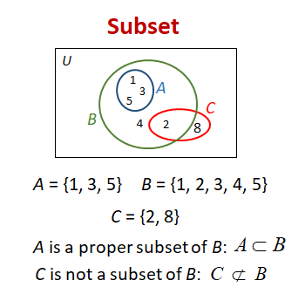A subset is a set where all of its elements are contained within another, larger set.

Empty set :

A set which does not contain any element is called an empty set, or a Null set, or a void set. Empty set is denoted by the symbol φ or { }.

Universal set :

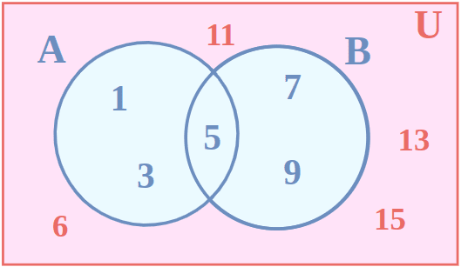A universal set, denoted by U, is a collection of all possible elements for a given context or problem.

Venn diagrams :

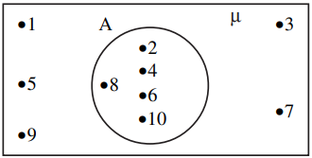(i) Consider that µ = {1, 2, 3, …., 10} is the universal set of which, A = {2, 4, 6, 8, 10} is a subset. Then the venn-diagrams is as:

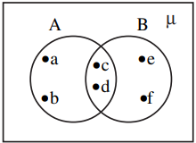(ii) Let A = {a, b, c, d} and B = {c, d, e, f}. Then we illustrate these sets with a Venn diagram as

Union sets :

* The union of A and B is the set which consists of all the elements of A and B and the common elements being taken only once. The symbol ‘µ’ is used to denote the union. Symbolically, we write A ∪ B and usually read as ‘A union B’.
* The union of the sets can be represented by a Venn-diagram as shown (shaded portion).

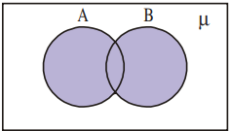

Intersection of sets :

* The intersection of sets A and B is the set of all elements which are common to A and B. i.e., those elements which belong to A and also belong to B. We denote intersection by A ∩ B. (read as “A intersection B”).
* 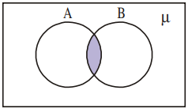The intersection of A and B can be illustrated in the Venn-diagram as shown in the shaded portion in the adjacent figure.

Disjoint set :

* 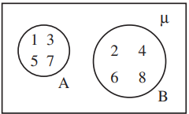Suppose A {1, 3, 5, 7} and B = {2, 4, 6, 8}. We see that there are no common elements in A and B. Such sets are known as disjoint sets. The disjoint sets can be represented by means of the Venn-diagram as follows:

Difference of sets :

* The difference of sets A and B is the set of elements which belong to A but do not belong to B. We denote the difference of A and B by A – B or simply “A Minus B”.
* 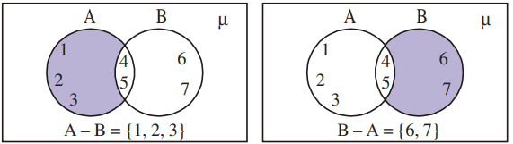The Venn diagram of A-B is as shown.

Photographs related to the topics :

